1. **Functionality:** This method does the following:
   1. Input a string
   2. Loop through each character in the string.
   3. In the loop check whether that character is UPPER CASE or not. If Upper case is found it returns true. If not found it returns False.

**Test cases:** ["this Is a test", “This is a test”]

**Expected result:** [True, True]

**Actual result:** [False, True

**Inference:** This function **doesn’t** serve the actual functionality

**RCA:** The problem with this logic is it returns False and breaks the loop for searching of Upper case character the moment it encounters a lower case character which is not intended. This will work only when the First character is Upper case. The highlighted code section is creating the issue.

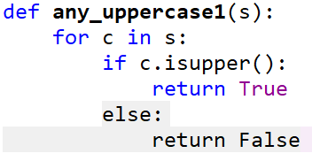

1. **Functionality:** 
   1. Input a string
   2. Loop through each character in the string.
   3. In the loop check whether the character **‘c’** is UPPER CASE or not.

**Test case:** "this Is a test"

**Expected result:** True

**Actual result:** False

**Inference:** This function **doesn’t** serve the actual functionality

**RCA:** In the loop instead of checking character of the string we are checking a hard-coded character **‘c’** is Upper case or not. Always this condition will result in False. The below code section is causing the issue.

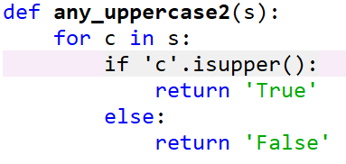

1. **Functionality:** 
   1. Input a string
   2. Loop through each character in the string.
   3. In the loop set the flag to the Boolean output

**Test case:** "this Is a test"

**Expected result:** True

**Actual result:**

**Inference:** This function **doesn’t** serve the actual functionality

**RCA:**

1. **Functionality:** 
   1. Input a string
   2. Loop through each character in the string.

**Test case:** "this Is a test"

**Expected result:** True

**Actual result:**

**Inference:** This function **doesn’t** serve the actual functionality

**RCA:**

**Functionality:**

* 1. Input a string
  2. Loop through each character in the string.

**Test case:** "this Is a test"

**Expected result:** True

**Actual result:**

**Inference:** This function **doesn’t** serve the actual functionality

**RCA:**

|  |  |  |  |  |  |  |  |
| --- | --- | --- | --- | --- | --- | --- | --- |
| **Sl. No** | **Functionality** | **Test cases** | **Expected results** | **Actual results** | **Inference** | **RCA** | **Code snippet causing the issue** |
| a | a. Input a string b. Loop through each character in the string. c. In the loop check whether that character is UPPER CASE or not. If Upper case is found it returns true. If not found it returns False. | "this Is a test" | TRUE | FALSE | This function **doesn’t** serve the actual functionality | The problem with this logic is it returns False and breaks the loop for searching of Upper case character the moment it encounters a lower case character which is not intended. This will work only when the First character is Upper case. The highlighted code section is creating the issue. | else:  return False |
|  |  | "This is a test" | TRUE | TRUE |  |  |  |